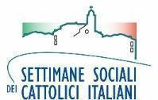
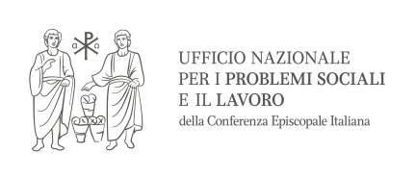
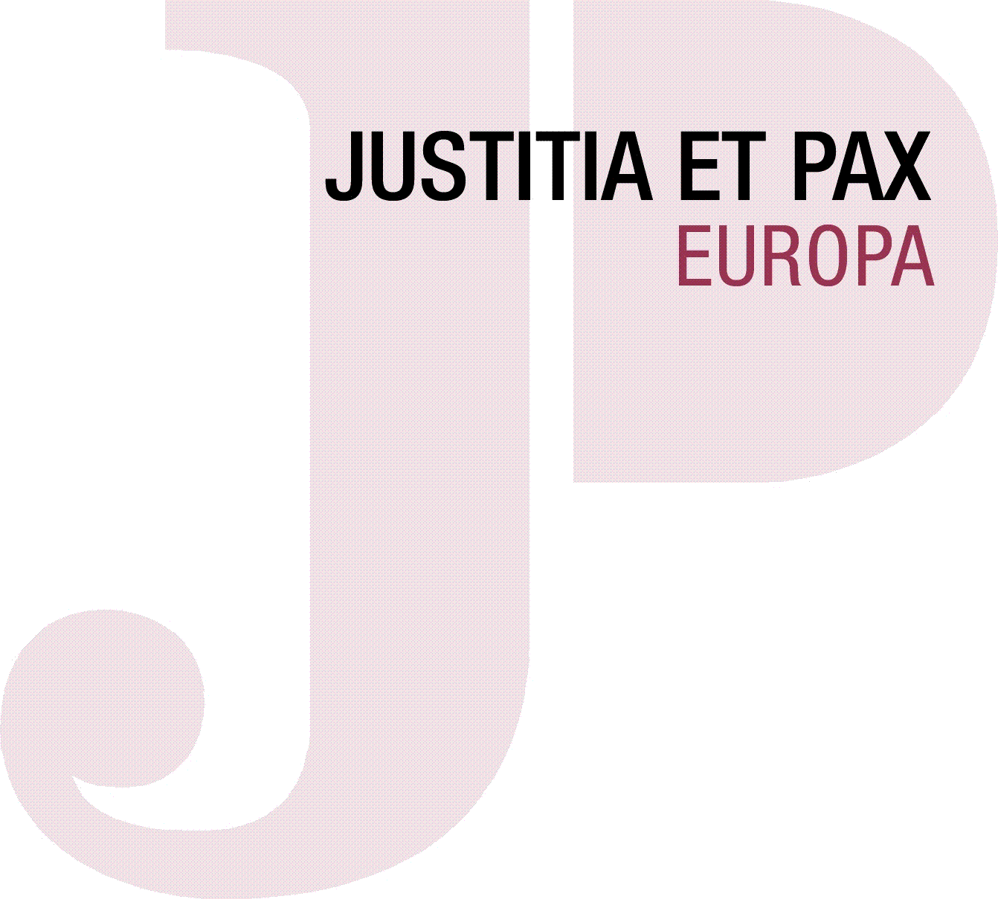
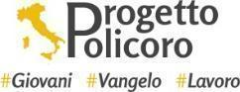
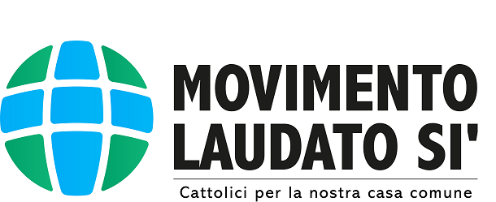
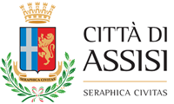
with the patronage of:

International workshop and Justice and Peace Europe
General Assembly
Peace, integral ecology and synodality

Assisi, 7th-10th October 2022
Hotel: Casa Leonori, Via Giosuè Borsi, 11/13
Santa Maria degli Angeli, Assisi PG

Friday 7th of October

13:30 Departure of Shuttle bus from Fiumicino Airport to Assisi

16:00 - 17:00 Arrival and check-in

17:30 Meeting in front of the hotel and departure for the Sacred Convent of Assisi

18:00 Opening prayer at the Sacred Convent (Chapel of brother Elia)
by Fr. Simone Tenuti and Young people of Policoro Project

18:30 Opening ceremony (Room of Peace)
- Greetings:
- Msgr. Noël Treanor, President Justice and Peace Europe
- Msgr. Luigi Renna, Archbishop of Catania, President of the Episcopal Commission for Social Problems and Work, Justice and Peace
- «The spirit of Assisi, city of Peace and the Righteous»: Stefania Proietti, Mayor of Assisi
- «Integral ecology and synodality»: Fr. Giacomo Costa, Jesuit and Member of the Scientific Committee and organizer of the Social Weeks of Italian Catholics, and of the National Coordination Group of the Synodal Journey. Member of the coordination committee of the 2021-23 Synod set up at the General Secretariat of the Synod of Bishops

20:00 Exhibition of the flag-wavers of Assisi (Inferior Square of Saint Francis)

20:30 Dinner in Assisi (Restaurant San Francesco)

22.00 Return to the Hotel

Saturday 8th of October

7:30 Holy Mass (Chapel in the hotel)
Presided over by Msgr. Noël Treanor, President of Justice and Peace Europe

8.15 Breakfast

9.00 Departure for Rondine, Cittadella della Pace (Arezzo)

11.00 The «Rondine method: beyond the enemy, building peace»: Franco Vaccari, President of Rondine Cittadella della Pace.
The mission of Rondine Cittadella della Pace is to promote the creative transformation of conflict through the experiences of young people who discover the human being in their enemy

12.00 Visit of Rondine by some young people of the Cittadella della Pace, coming from different countries

13.00 Light lunch

14.30 - 16.30 Working Groups in a synodal style (workshop) coordinated by young people:
- PEACE AND NEW MODELS OF ECONOMY: by Irene Ioffredo - Federico Cutrone;
- PEACE AND ENERGY TRANSITION: by Pietro Rufolo - Sara Farris;
- PEACE AND ECOLOGICAL CONVERSION: by Francesco Costa - Concetta Ricciardi
- PEACE and WORK: by Matteo Lovecchio - Elisabetta Guenzi.

16:30 Coffee break

17.00 Report in plenary of the working groups

18.00 Return to Assisi

20.00 Dinner in the hotel

21.15 Viewing of documentary film “The Letter”, produced by Laudato Si’ Movement with production company Off The Fence, in collaboration with the Vatican (optional)

Sunday 9th of October

Breakfast

8:30 Departure for Assisi

9:30 Holy Mass in Assisi (Shrine of Renunciation)
Presided over by Msgr. Luigi Renna, Archbishop of Catania

10.30 Symbolic Action:
«Walking together with St. Francis for peace and ecological conversion» by Laudato Si’ Movement
- Room of Renunciation of Saint Francis (The cry of the poors and the cry of the earth)
- Church of St. Damian (Canticle of Creatures)

13:30 Lunch in the hotel

16:30 General Assembly (opening):
- Annual “Justice and Peace Lecture” by Isabel Cuenca, Arnaud Gorgemans, Maria Hammershoy, outgoing members of the ExCO and vice-president
- Exchange with H.E. Michael Cardinal Czerny sj, Prefect of the Dicastery for Promoting Integral Human Development
- Final Declaration of the International Justice and Peace Europe Workshop
- Report of the Presidency
- Elections

19:30 Dinner in the hotel

21:00 Visit to Giotto's frescoes in the Upper Basilica of St. Francis, (optional)

Monday 10th of October

Breakfast

7:30 Departure on foot for the Basilica of Saint Mary of the Angels

8:00 Holy Mass in the Porziuncola (Refettorietto)
Presided over by Msgr. Domenico Sorrentino, Bishop of Assisi-Nocera Umbra-Gualdo Tadino-Foligno

9:30 General Assembly

13:00 Conclusions and buffet lunch in the hotel

13:30 Greetings and departures (Departure of the shuttle to Fiumicino Airport)

